# Create the API

1. The API that is going to be created in this hands-on will aggregate the results from Product Master, Product Assets and Product Reviews services and return an aggregated result for a given product (GTIN).
2. In the Publisher Portal, add a new API manually as explained in the earlier hands-on with the following configuration.

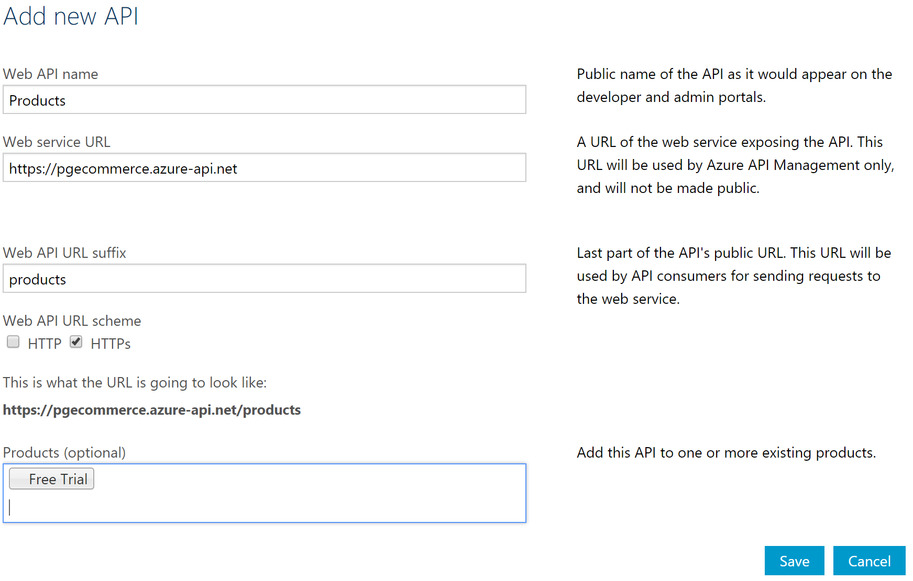

*Note: the backend “Web service URL” configured here is a dummy value, i.e., same as the public URL of the API Gateway.*

1. Add a new operation to the API with values as shown below.

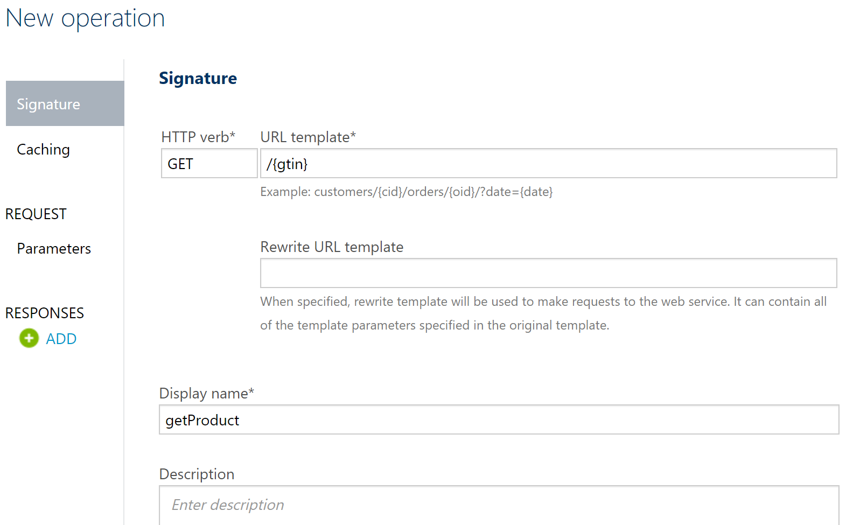

# Configure Policy for Aggregation

1. Go to the policy editor for the abovecreated operation. Add a new policy with code from the attached file.
2. Ensure that the API URLs are updated with the Azure API Management domain that has been created.



1. Look at some of the key service policies being used here:

|  |  |
| --- | --- |
| Policy Name | Used for |
| set-variable | * To get the product GTIN passed in the request URL and set it to a variable. This value is then passed to other downstream services. * To set the Bazaarvoice code from the 1st API’s response into a variable, which is then used as input to the Product Review API |
| send-request | * To call a backend API and store its results into a variable |
| return-respone | * To return a custom API response |
| set-body | * To aggregate the results from the 3 APIs and return as part of return-response |

# References

* Policy reference – <https://docs.microsoft.com/en-us/azure/api-management/api-management-advanced-policies>
* Send Request policy – <https://docs.microsoft.com/en-us/azure/api-management/api-management-advanced-policies#SendRequest>